**Cost understanding**

**Support document**

1. *Differences between prototype and mass production*

Different types of manufacturing processes: Machining (Milling, Turning), Laser and waterjet cut, 3D printing, Stamping, Foundry, Forging, Broaching, Weldments, Injection molding, …

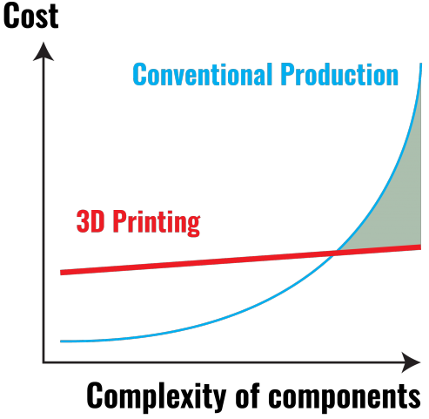

*Comparison of 3D printing versus conventional production: cost versus complexity*

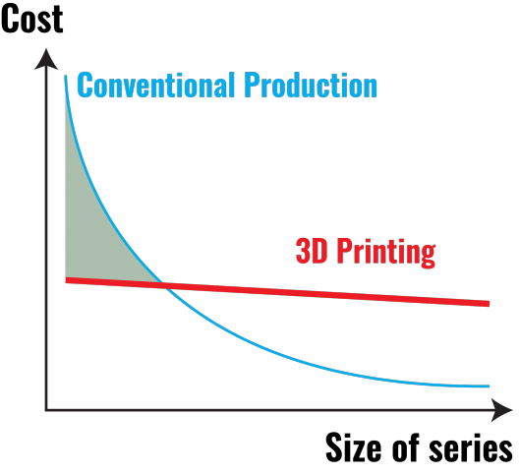

*Comparison of 3D printing versus conventional production: cost versus size of series*

1. *Resource and cost planning*

*Global resource planning*

See V cycle drawing.

|  |  |  |  |
| --- | --- | --- | --- |
| **End of…** | **Previsionnal date** | **Real date** | **Delay (in days)** |
| High level design | 6 sept. 2018 | 13 sept. 2018 | **7 days** |
| Detailed design | 13 nov. 2018 | 20 nov. 2018 | **7 days** |
| Fabrication & unit testing | 15 feb. 2019 | 8 mar. 2019 | **21 days** |
| System testing & integration | 16 mar. 2019 | 5 apr. 2019 | **20 days** |
| Roll out | 10 apr. 2019 | 10 apr. 2019 | **0 days** |
| First testing | 20 apr. 2019 | 27 apr. 2019 | **7 days** |

*Detailed resource planning*

Utilisation of Gantts to plan and monitor the work.

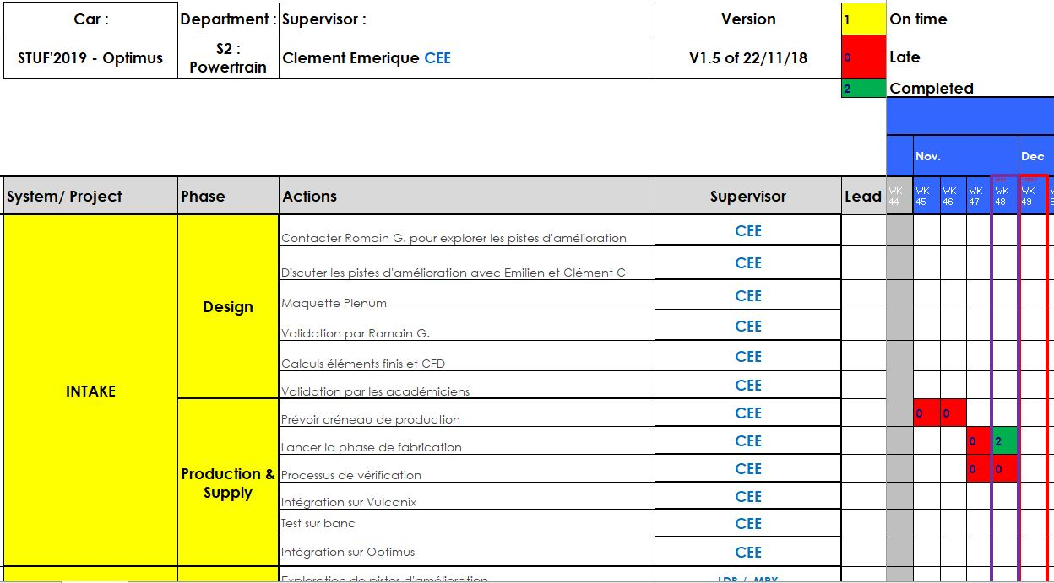

*Example of Gantt layout*

*Manufacturing planning*

* Gantt of the production phase (Manufacturing_Gantt)
* Excel of the repartition of the production between our partners, sponsors and suppliers (Manufacturing_framework)

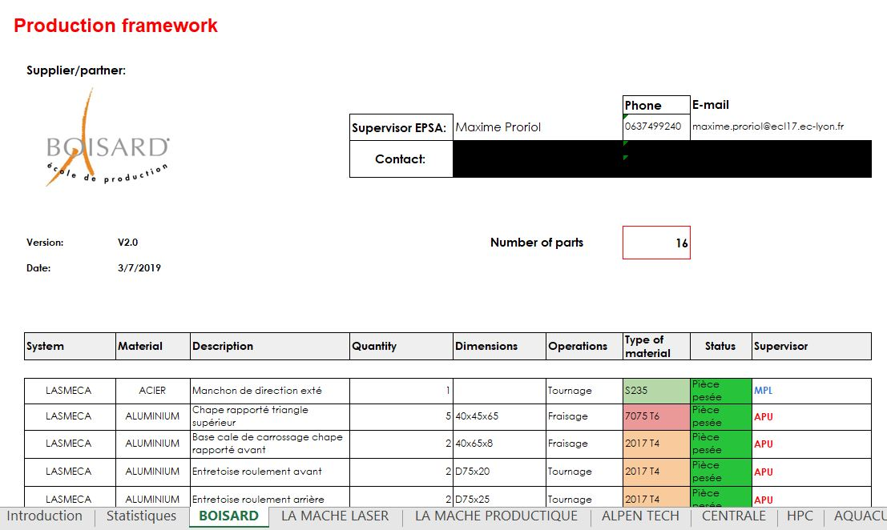

*Production framework layout*

*Cost planning*

See *Previsionnal Expenses* drawing.

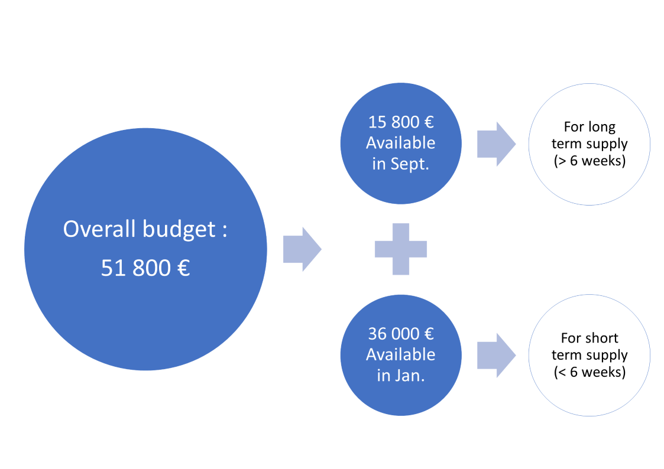

*Example of Gantt layout*

|  |  |  |  |  |
| --- | --- | --- | --- | --- |
| **System** | **Previsionnal** | **Real** | **Differences (€)** | **Differences (%)** |
| Suspension | 12 630,00 € | 19 480,00 € | 6 850,00 € | 35% |
| Powertrain | 14 680,00 € | 14 046,00 € | -634,00 € | -5% |
| Electrical | 6 810,00 € | 6 893,00 € | 83,00 € | 1% |
| Frame & body | 880,00 € | 2 005,00 € | 1 125,00 € | 56% |
| Miscellaneous | 11 400,00 € | 9 994,00 € | -1 406,00 € | -14% |
| Total | 46 400,00 € | 52 418,00 € | 6 018,00 € | 11% |
| Budget | 51 800,00 € | 52 600,00 € |  |  |
| Financial provisions | 5 400,00 € | 182,00 € |  |  |

*Summary of previsionnal and real expenses*

1. *Financial and production risk management*

*An example of a financial risk*

Supply of wheels’ bearings:

* Delay of delivery due to absence of stock
  + Initially planned on March
  + Delivery delayed to the beginning of June
* To respect the roll-out deadline, wheels bearings supplied with the budget
  + Diminution of the financial provision

*An example of a production risk*

A fire destroyed the workshops of our partner during the manufacturing of the uprights and hubs. The team reacted quickly to move the production to another partner and to the university workshop.

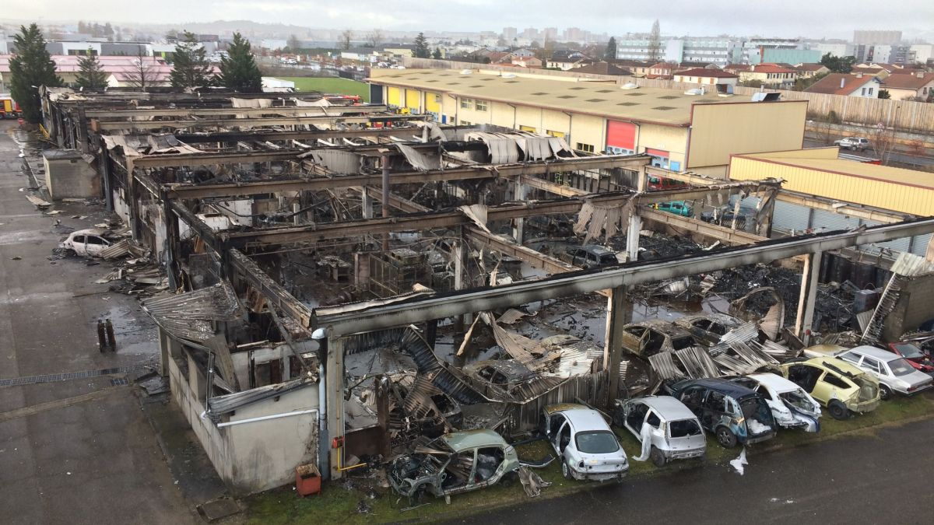

*Fire in the workshops of our partner Boisard*

1. *Make or buy decisions*

See ratio of price versus weight saved.

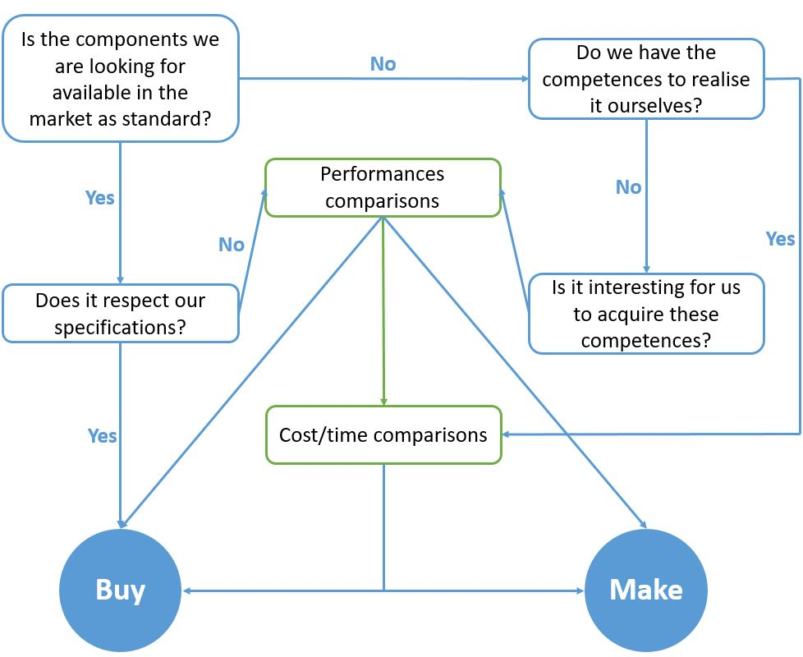

*Diagram to illustrate buy and made decisions*